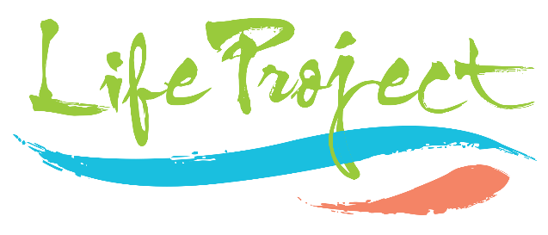

GIVING TO THE LIFE PROJECT
Boost your donation by 25p for every £1 you donate.
Gift Aid can be reclaimed by the charity from the tax you pay for the current tax year.
Your address is needed to identify you as a current UK taxpayer.

In order to Gift Aid your donation please tick the box below:

I want to Gift Aid my donation of £ and any donations I make in the future or have made in the past 4 years:

To: The Life Project

I am a UK taxpayer and understand that if I pay less Income Tax and/or Capital Gains Tax in the current tax year than the amount of Gift Aid claimed on all my donations it is my responsibility to pay any diﬀerence.

My Details

Please complete in capital letters

Title First name or initial(s)

Surname

Full Home address

Postcode

Email

Signature _ Date

I would like to receive the regular newsletters and special updates from The Life Project

Please notify The Life Project if you:
- Want to cancel this declaration
- Change your name or home address
- No longer pay suﬃcient tax on your income and/or capital gains

If you pay Income Tax at the higher or additional rate and want to receive the additional tax relief due to you, you must include all your Gift Aid donations on your Self-Assessment tax return or ask HM Revenue and Customs to adjust your tax code.

Privacy Statement: The Life Project (Bath) complies with its obligations under the GDPR by keeping personal data up to date, by storing and destroying it securely, by not collecting or retaining excessive amounts of data, by protecting personal data from loss, misuse, unauthorised access and disclosure and by ensuring that appropriate technical measures are in place to protect personal data.

GIVING TO THE LIFE PROJECT
Boost your donation by 25p for every £1 you donate.
Gift Aid can be reclaimed by the charity from the tax you pay for the current tax year.
Your address is needed to identify you as a current UK taxpayer.

In order to Gift Aid your donation please tick the box below:

I want to Gift Aid my donation of £ and any donations I make in the future or have made in the past 4 years:

To: The Life Project

I am a UK taxpayer and understand that if I pay less Income Tax and/or Capital Gains Tax in the current tax year than the amount of Gift Aid claimed on all my donations it is my responsibility to pay any diﬀerence.

My Details

Please complete in capital letters

Title First name or initial(s)

Surname

Full Home address

Postcode

Email

Signature _ Date

I would like to receive the regular newsletters and special updates from The Life Project

Please notify The Life Project if you:
- Want to cancel this declaration
- Change your name or home address
- No longer pay suﬃcient tax on your income and/or capital gains

If you pay Income Tax at the higher or additional rate and want to receive the additional tax relief due to you, you must include all your Gift Aid donations on your Self-Assessment tax return or ask HM Revenue and Customs to adjust your tax code.

Privacy Statement: The Life Project (Bath) complies with its obligations under the GDPR by keeping personal data up to date, by storing and destroying it securely, by not collecting or retaining excessive amounts of data, by protecting personal data from loss, misuse, unauthorised access and disclosure and by ensuring that appropriate technical measures are in place to protect personal data.

